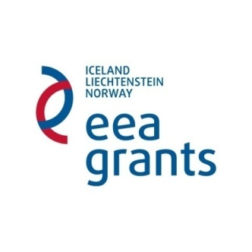

APPLICATION FORM OF THE FUND FOR BILATERAL RELATIONS

Project title: _____________________________________________________________________

Estimated period of implementation ___________________________________________________

Requested funds ____________________________________________________________________

Summary of the request
Summary includes a short presentation (up to 15 lines) with reference to at least the following: objectives, planned activities and expected results.

- Applicant

Name of the organisation (applicant)
Register number
Zip-code |  | City
Adress
Homepage
Contact person
Email |  | Phone

Background of the applicant organisation
Please describe the applicant organization's field of activity and highlight the main facts that support the organizations competence in tackling hate speech and working with asylum seekers (including previous experience with similar activities experience in the field, etc.).

- Partner

Name of the organisation
Register number
Zip-code |  | Zip-code
Adress
Homepage
Contact person
Email |  | Email

Background of the partner organisation
Please describe the partner organization's field of activity and highlight the main facts that support the organizations competence in tackling hate speech and working with asylum seekers (including previous experience with similar activities experience in the field, etc.).

If in addition to the partner mentioned above, there are other entities involved with the project that qualify as partners, please provide their information as exemplified in section 2.

- Objective of the proposal

Objective of the bilateral relations proposal
Please describe the objectives and expected results of the bilateral relations proposal

- Activities

No. | Activity title/ name | Short description of the activity (what to do, where and how it is performed, who participates etc.) | Responsible for carrying out the activity | Period of implementation (please indicate the month)

- Importance of the cooperation

Importance of the cooperation
Please describe the main advantages that your organisation could offer to a donor project partner and indicate benefit of partnership between the organizations.

- Budget - Please name the categories of expenses and prices (travelling expenses, rooms rental etc.)

Category of Expenses | Unit of measurement (hour, person, etc.) | Unit price | Total
5.
6.
7.
8.
(please insert additional rows if needed)
Total cost of the project (100%)

I certify that I am duly authorized to sign this application form and that the information provided is accurate. I confirm that planned bilateral activities will be conducted as described in this application and that the proposed expenditures are correct estimated.

Name___________________ (person authorised to sign the contract) Date ___________________

Digital signature

